

**Department Of Information Technology**

**JSPM’S**

**Jayawantrao Sawant College of Engineering, Hadapsar, Pune -28**

**A.Y. 2023-24**

**DSBDA Mini Project Report on**

“*Music Recommendation System”*

***Submitted by***

T190408571 – Vedant Baliram Dhage



This is to certify that, 3062 :- Vedant Baliram Dhage have successfully completed this mini project report entitled **“*Music Recommendation System*”,** under my guidance in partial fulfillment of the requirements for the degree of Bachelor of Engineering in Department of Information Technology, SPPU during the academic year 2022-23.

Date: -

Place: - Pune

Prof. D.A.Gaikwad

Guide

# Index

1. Abstract

1. Introduction

1. Project Specification

* 1. Problem Statement

* 1. Objectives

* 1. Requirement

* + 1. Hardware Requirement

* + 1. Software Requirement

1. System Architecture

1. Source Code

1. Conclusion

## 1. Abstract

This mini project presents a “music recommendation system” designed to enhance user satisfaction and engagement. Leveraging collaborative filtering and content-based techniques, the system analyzes user preferences and music attributes to generate personalized recommendations. The implementation includes a user interface for inputting preferences and viewing recommendations. Evaluation of the system's performance indicates its effectiveness in suggesting relevant music items to users. Through this project, we aim to demonstrate the practical application of machine learning in improving user experiences in the realm of music consumption. The system provides a platform for users to discover new music tailored to their tastes, thereby fostering a more enjoyable and diverse listening experience. Overall, this project highlights the potential of recommendation systems to positively impact user interactions with digital music platforms, paving the way for future developments in personalized music discovery.

## 2. Introduction

In today's digital landscape, the world of music has undergone a transformative shift. With the advent of streaming services, music lovers are no longer limited by physical constraints or geographic boundaries when it comes to accessing their favorite tunes. However, amidst this abundance lies a significant challenge: how do users navigate the vast ocean of music to find the gems that resonate with their individual tastes?

Enter music recommendation systems, powered by the amalgamation of machine learning algorithms and user data. These systems serve as personalized curators, offering tailored suggestions based on an individual's listening history, preferences, and even mood. By analyzing vast amounts of data, ranging from user interactions to intricate musical attributes, recommendation systems aim to bridge the gap between users and the ever-expanding universe of music.

This mini project delves into the realm of music recommendation systems, aiming to design, develop, and evaluate a system that enhances user satisfaction and engagement. Through a fusion of collaborative filtering and content-based approaches, the system endeavors to unravel the intricacies of user preferences and musical characteristics, ultimately delivering recommendations that resonate with each user's unique sensibilities.

Beyond mere algorithmic prowess, this project emphasizes the human-centric aspect of music discovery. By prioritizing user experience and interaction design, the project seeks to create an intuitive and immersive platform where users can seamlessly explore, discover, and share their musical passions.

Through this exploration, we not only aim to showcase the capabilities of machine learning in the domain of music recommendation but also to underscore the profound impact such systems can have on shaping the way we consume and interact with music in the digital age. As we embark on this journey, we envision a future where music recommendation systems serve as trusted companions, guiding users on a melodic odyssey of discovery and delight.

## 3. Project Specification

**3.1 Problem Statement:**

Developing a music recommendation system that utilizes machine learning techniques to deliver personalized recommendations, enhancing user satisfaction and engagement in navigating the vast landscape of digital music.

**3.2 Objectives:**

* Implement collaborative filtering and content-based approaches to analyze user preferences and music attributes.

* Develop an intuitive user interface for inputting preferences and displaying recommendations.
* Process large volumes of user data and music metadata to generate personalized recommendations in real-time.

* Enhance user satisfaction and engagement by providing accurate and relevant music recommendations tailored to individual tastes.

* Demonstrate the potential of recommendation systems to positively impact user interactions with digital music platforms.

**3.3 Requirements:**

**3.3.1 Hardware Requirements:**

* A computer system capable of running data analysis and modeling software.

* Adequate storage capacity to accommodate the dataset and analysis results.

**3.3.2 Software Requirements:**

* Python programming language (version 3.x) for data analysis and modeling.

* Jupyter Notebook or any Python IDE for code development and execution.

* Machine learning libraries/frameworks: Scikit-learn, TensorFlow, or PyTorch for implementing collaborative filtering and content-based recommendation algorithms.

## 4. System Architecture

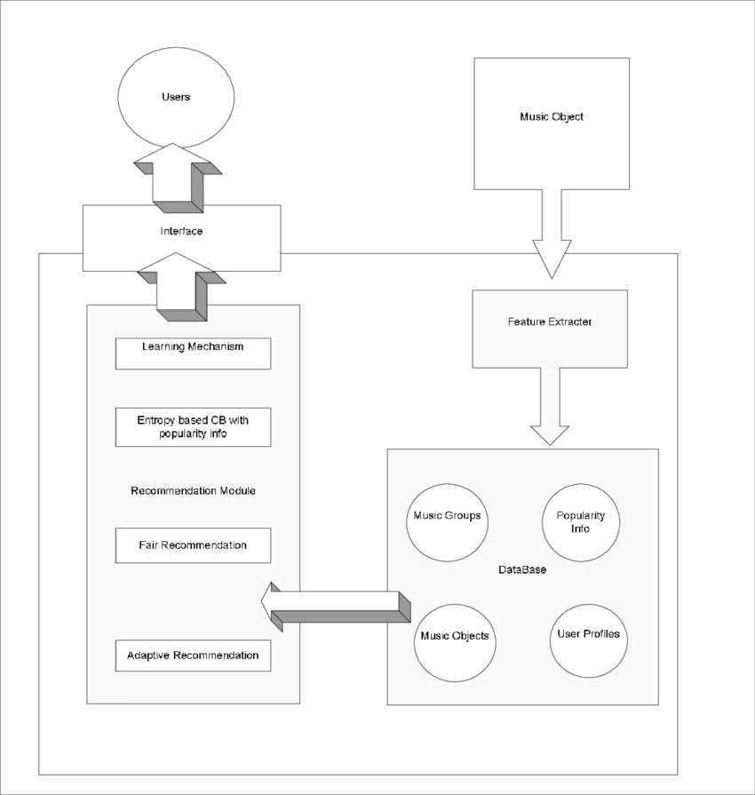

**5. Source Code**

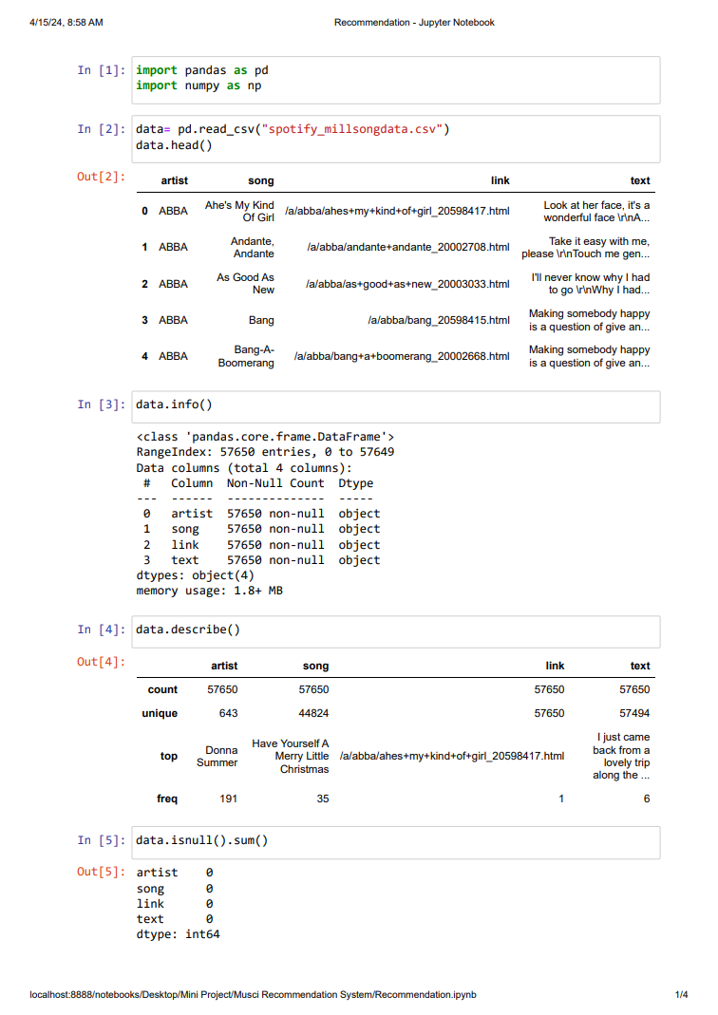

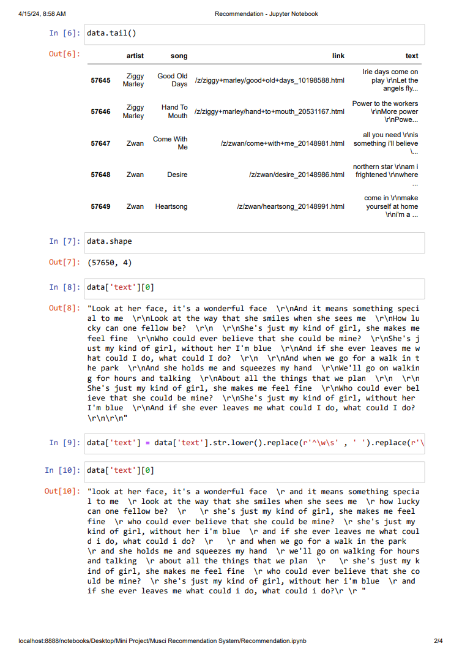

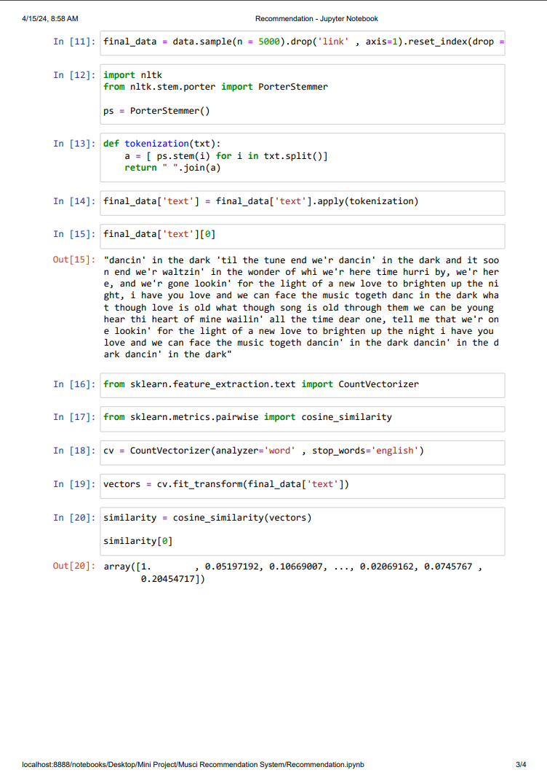

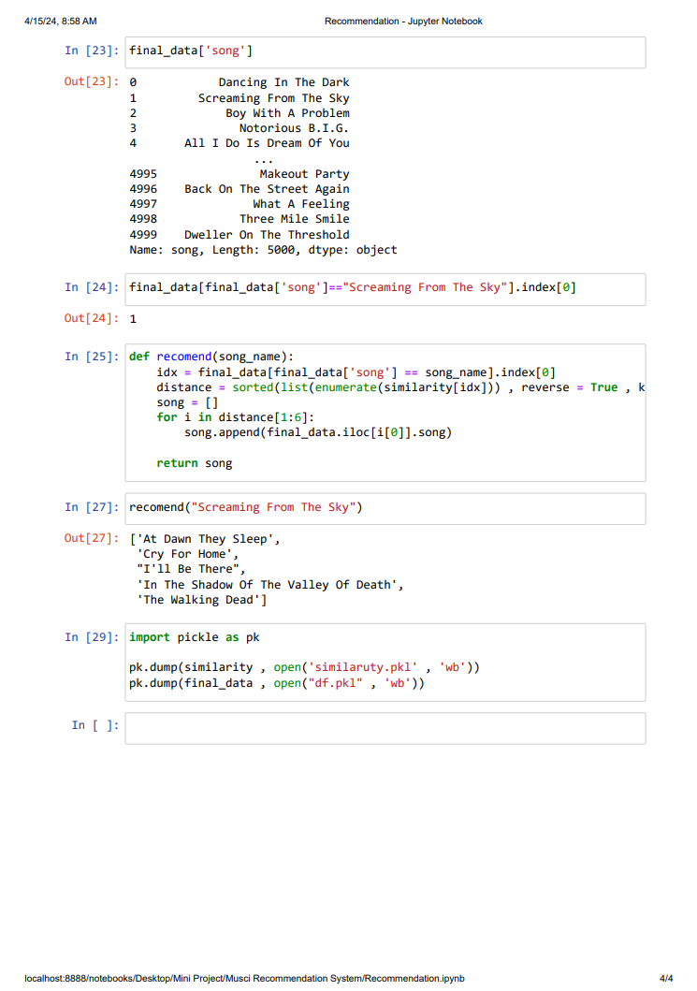

## 6. Conclusion

In conclusion, the music recommendation system represents a significant step forward in enhancing user engagement and satisfaction within the digital music landscape. Through the fusion of machine learning techniques, intuitive user interfaces, and efficient data management, the system adeptly addresses the challenge of navigating the vast expanse of musical content. By leveraging collaborative filtering and content-based approaches, it delivers personalized recommendations tailored to individual preferences, thus enriching the user experience. Moreover, the integration of user feedback mechanisms ensures continual refinement of recommendation quality, allowing the system to adapt to evolving tastes and preferences. Ultimately, this project underscores the transformative potential of technology in revolutionizing how we interact with music, empowering users to explore diverse genres and artists while fostering a deeper connection with the music they love.